ADCS:

CDH:

1. Model it as a box the dimensions of the onboard computer + FPGA + SD card -- they will need to connect wires to payload’s computer (so maybe don’t make the 2 computers too far apart?) but they okayed us basically putting everything in a box

Propulsion:

1. Aerojet Rocketdyne MR-111: Tara
   1. Drawing: 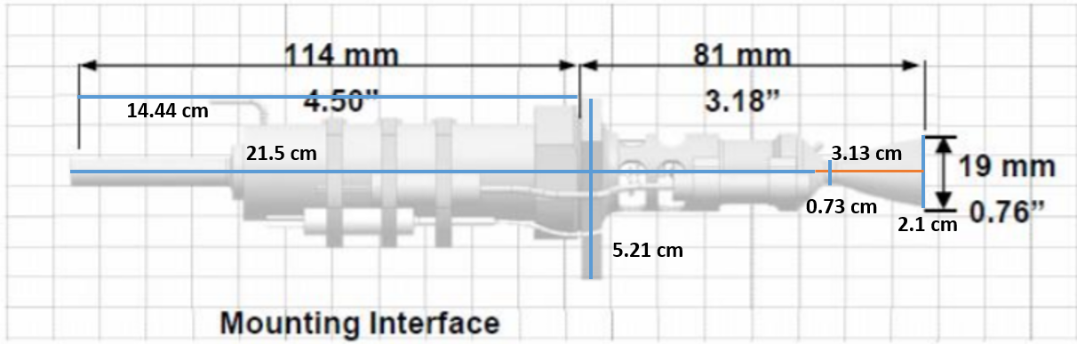
   2. The MEL lists the dimensions as 0.225 m length (should be 0.195 from the dimensions in the diagram in the data sheet), 0.019 m diameter, but the maximum diameter of the interior part seems to be much greater than that
   3. 0.019 m in reality = 0.021 m in PPT. Max diameter is 0.0521 m in ppt * (0.019 m real / 0.021 m PPT) = 0.0471 m real
      1. **So make the interior part a cylinder with diameter 0.0471 m**
   4. Then we need to figure out the length of the interior and exterior portions.
      1. The interior portion is 0.215 m in PPT, and along the horizontal axis, 0.114 m real = 0.1444 m PPT. Interior part: 0.215 m PPT * (0.114 m real/0.1444 m PPT) = 0.1697 m real
      2. **So make the interior part a cylinder with length 0.1697 m**
      3. The exterior portion is 0.0313 m in PPT: 0.0313 m PPT * (0.114 m real/0.1444 m PPT) = 0.0247 m real
      4. **So make the exterior part a cut-off cone with length 0.0247 m**
   5. The exterior part (nozzle) will be a cut off cone. The minimum diameter is 0.0073 m PPT * (0.019 m real / 0.021 m PPT) = 0.0066 m real
      1. **So make the exterior part a cut-off cone with minimum diameter 0.0066 m and maximum diameter 0.019 m**